

40

Target: ___/40 or ____ % 👍 👎

40

40

**Year 7 HASS- Geography**

***Task 2: In Class Test (5% weighting)***

***(Introduction to Geography and Water in the World)***

***Marking Guide***

Name:________________________ Teacher: ___________________

**Time: 5 minutes reading time and 40 minutes working time.**

**Section One: Multiple Choice**

Read each key term, or statement, and circle only one option from A-D with a pencil as your response.

(12 marks)

1. What form of precipitation is the most common in Australia?
2. Rain
3. Hail
4. Sleet
5. Snow
6. What does the ‘I’ in SPICESS stand for?
7. Internationalism
8. Interconnection
9. Infiltration
10. Intercontinental
11. Which of the following is not a renewable resource?
12. Solar
13. Wind
14. Coal
15. Hydroelectricity
16. Evaporation, precipitation and condensation make up the _____________________.
17. Ecosystem
18. Lake effect
19. Weather pattern
20. Water cycle
21. The water cycle is driven by the:
22. Moon
23. Clouds
24. Oceans
25. Sun
26. When water evaporates directly from plants, it’s called:
27. Condensation
28. Sublimation
29. Transpiration
30. Precipitation
31. The **O** in BOLTSS stands for;
32. Orientation
33. Orographic
34. Oceans
35. Organisation
36. During evaporation water goes from a _________________ to a ___________________.
37. Solid, gas
38. Liquid, gas
39. Liquid, solid
40. Liquid, plasma
41. What is the acronym used to remember the processes in the Water Cycle?
42. SPICESS
43. SHEEPT
44. BOLTSS
45. PERTIC
46. The S in SHEEPT stands for;
47. Sustainability
48. Social
49. Scale
50. Space
51. The form of geography that studies the natural features and environments of the earth is known as;
52. Physical
53. Cultural
54. Human
55. Natural
56. The largest percentage of the earth’s water is found in the:
57. Oceans
58. Ice caps
59. Lakes
60. Ground as groundwater

**End of Section One**

**Section 2: Short Answer Response** (2 marks)

1. The PQE method stands for (*The first letter has been completed for you*) ;

**P***attern*

**Q**uantify (1 mark)

**E**xception (1 mark)

1. Label the following diagram with the **four** cardinal points;

(4 marks)

North

(1 mark for each)

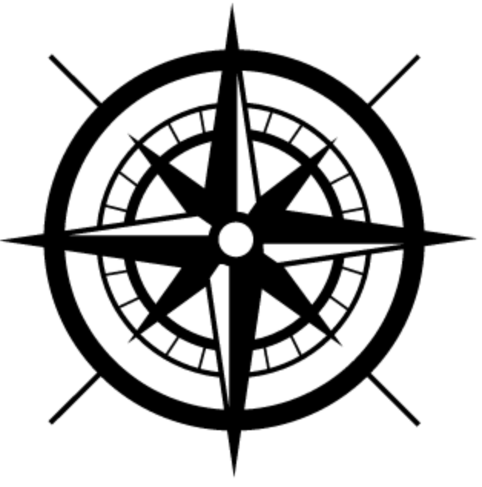

West

East

South

1. Define the term “environmental resource” and provide examples to support your definition.

(2 marks)

An environmental resource is anything in the biophysical environment that people use. 1 mark

Any of the following examples will be awarded one mark; air, wind, water, forests, plants and animals. 1 mark

1. List four uses of water. (2 marks)

Any of the following answers will receive ½ mark each.

* Drinking
* Bathing
* Irrigation
* Aquaculture
* Livestock
* Mining

1. Differentiate between renewable and non-renewable resources and provide examples to support your response.

(4 marks)

* 1 mark for accurate definition of renewable resource
* 1 mark for accurate definition on non-renewable resource
* ½ mark for each example (max of 2 examples)
* 1 mark if the answer is well constructed, uses full sentences and uses terminology such as “whereas” “on the other hand” etc

1. Categorise the list of resources below into the correct category. (2 marks)

|  |  |  |  |  |  |
| --- | --- | --- | --- | --- | --- |
| *Coal* | *Tides* | | *Fresh Air* | | *Oil* |
| *Solar* | *Plants and Animals* | | *Natural Gas* | | *Wind* |
| Renewable | | Non-Renewable | | Continuous | |
| **Fresh Air**  **Plants and animals**  **(½ mark)** | | **Coal**  ½ mark  **Oil**  **Natural Gas**  ½ mark | | **Tides**  **Solar**  **Wind**  ½ mark | |

1. Refer to Source 5.21 “Typical household water use in Australia” to answer the questions below; (2 marks)

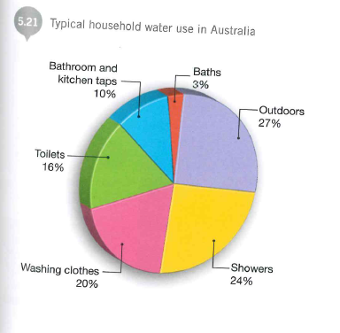

1. What percentage of household water use is used on baths?

3%

1. What is the combined percentage of water used on baths, showers and toilets?

43%

1. a) List the 3 types of rainfall: (3 marks)
2. Convectional
3. Frontal
4. Orographic

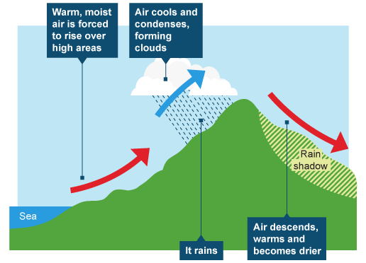b) Referring to the diagram below – which type of rainfall is depicted? (1 mark)

Orographic rainfall

1. a) Label the diagram of the water cycle with following processes. (5 marks)

• Evaporation

• Transpiration

• Condensation

• Precipitation

• Run Off

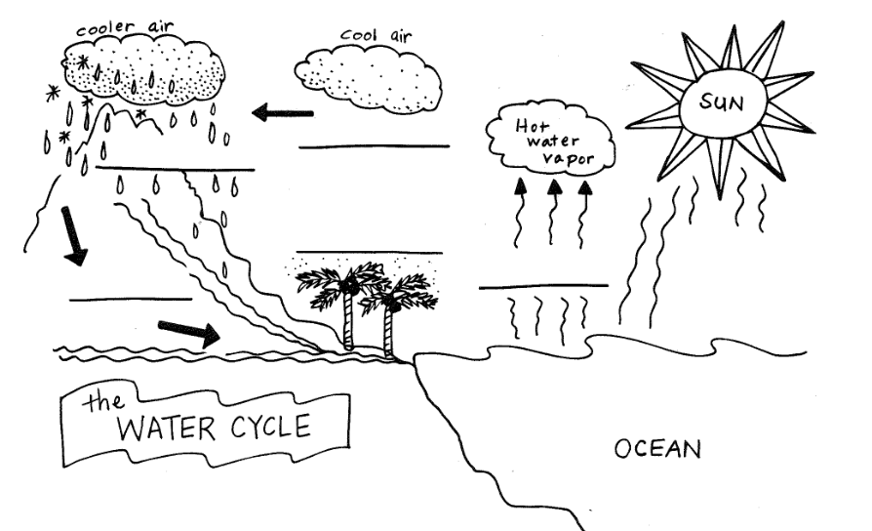

**Runoff**

**Transpiration**

**Evaporation**

**Condensation**

**Precipitation**

1. Which part of PERTIC is missing from the diagram above? (1 Mark)

Infiltration

**END OF TEST**